# Lab 3 Decision Structures

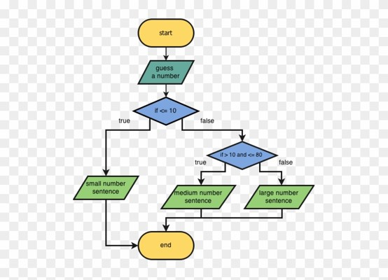

Problem 1. **Volume Discounts**

Geekware Software Company’s biggest seller software package sells for $149 each. Quantity discounts are given according to the following table:

|  |  |
| --- | --- |
| Quantity | Discount |
| 10-49 | 10% |
| 50-99 | 20% |
| 100-149 | 30% |
| 150 or more | 40% |

Write a program that asks the user to enter the number of packages purchased. The program should then display the dollar amount of the discount (if any) and the total amount of the purchase after discount**.**

**Design.** You will be using a flow chart to design your program. You can use this free tool: draw.io to make your flow chart. Once you have opened the application:

1. Select: Create New Diagram
2. Select: Flowcharts >> Press Create
3. Using the shapes and lines at the left, create a flowchart for your program logic.
4. To Rename File: File >> Rename >> yourlastname_lab3
5. To Save as pdf: Export as >> pdf
6. If for some reason this doesn’t work, you can do File>>Save As and save it as an .XML file.

You may also use Powerpoint to draw your flowchart if you prefer.

See Section 3.4 for information and examples of nested decision structures and multiple nested decision structures.

**Code.** Write your program in Python using the above steps. Save your program as a .py file with the name *yourlastname*_Lab3.py

**Output.** Your program should produce correctly labeled output with dollar amounts rounded to 2 decimal places and dollar signs displayed. See section 2.8 More About Output. Sample dialog:

Enter the number of packages purchased: 53

Discount Amount: $ 1,579.40

Total Amount: $ 6,317.60

>>>

**Programming Style Requirements.**

Comments – Begin your program with a comment that includes: a) your name, b)program status – either “Complete” or describe any incomplete or non-functioning part of your program c)A 1-3 line description of what the program does.

Variable names – use meaningful variable names such as total_taxes or num_cookies.

Named constants – Use named constants for all number values that will not be changed in the program.

You will have two files to turn in to Blackboard. One .py file and one flow chart pdf. Attach all files before pressing SUBMIT.